GCSE History Paper Two

Elizabethan England Exam Questions

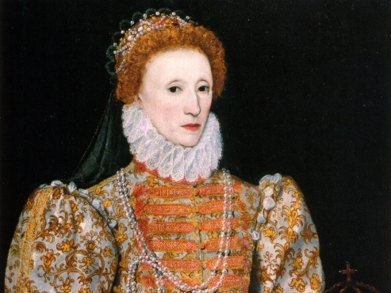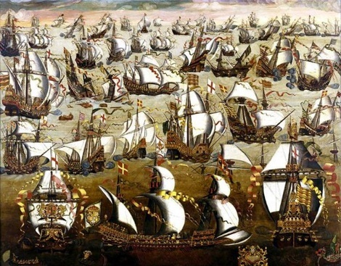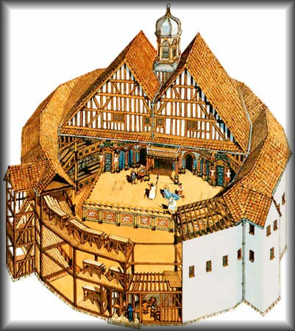

1. Interpretation question (8 marks = 10 minutes)
e.g. How convincing is Interpretation A about…
Hint: DO NOT USE PROVENANCE! Select aspects of the interpretation you can support and/or challenge using your subject knowledge.

2. Importance question (8 marks = 10 minutes)
e.g. Explain what was important about…
Hint: One reason for importance per paragraph with supporting detail. Multiple paragraphs needed.

3. Write an account question (8 marks = 10 minutes)
e.g. Write an account of…
Hint: Include plenty of subject knowledge and organise your ideas into separate paragraphs.

4. Site question (16 marks = 20 minutes)
e.g. “Statement” plus question. The statement is likely to focus on the functions and features of your nominated site so make sure you revise these!
Hint: One idea per paragraph with examples from your nominated site leading to a conclusion.

Interpretation Question

Interpretation A

Marriage and motherhood would deprive her temporarily – perhaps permanently – of the authority and power to rule. To share power she would hate. To renounce it she would find it intolerable.
J. Hurstfield, Elizabeth and the Unity of England, 1960.

How convincing is Interpretation A about Elizabeth’s reasons not to marry? Explain your answer based on your contextual knowledge and what it says in Interpretation A.

One way in which Interpretation A is convincing/unconvincing is because it says/does not say…

From my own subject knowledge, …

A second way in which Interpretation A is convincing/unconvincing is because it says/does not say…

From my own subject knowledge, …

A final way in which Interpretation A is convincing/unconvincing is because it says/does not say…

From my own subject knowledge, …

Interpretation Question

Interpretation A

Elizabeth’s experience was very limited. Her life had been led almost exclusively in the seclusion of country houses, with only an occasional short visit to Court.

W. McCaffrey, Elizabeth I, 1993.

How convincing is Interpretation A about Elizabeth’s early life? Explain your answer based on your contextual knowledge and what it says in Interpretation A.

One way in which Interpretation A is convincing/unconvincing is because it says/does not say…

From my own subject knowledge, …

A second way in which Interpretation A is convincing/unconvincing is because it says/does not say…

From my own subject knowledge, …

A final way in which Interpretation A is convincing/unconvincing is because it says/does not say…

From my own subject knowledge, …

Interpretation Question

Interpretation A

How convincing is Interpretation A about Elizabethan theatre? Explain your answer based on your contextual knowledge and what it shows in Interpretation A.

One way in which Interpretation A is convincing/unconvincing is because it shows/does not show…

From my own subject knowledge, …

A second way in which Interpretation A is convincing/unconvincing is because it shows/does not show…

From my own subject knowledge, …

A final way in which Interpretation A is convincing/unconvincing is because it shows/does not show…

From my own subject knowledge, …

Interpretation Question

Interpretation A

The Tudor poor law was more impressive on paper than in fact. Careful study of parish accounts for Elizabeth’s reign has shown that a poor rate was levied only in times of dire emergency…It was private charity that bore almost the entire burden of poor relief right down to 1660…It has been estimated that down to 1660 only 7% of the money devoted to poor relief was raised by taxation.
Sinclair Atkins, England and Wales under the Tudors, 1975.

How convincing is Interpretation A about the success of the Elizabethan Poor Law? Explain your answer based on your contextual knowledge and what it says in Interpretation A.

One way in which Interpretation A is convincing/unconvincing is because it says/does not say…

From my own subject knowledge, …

A second way in which Interpretation A is convincing/unconvincing is because it says/does not say…

From my own subject knowledge, …

A final way in which Interpretation A is convincing/unconvincing is because it says/does not say…

From my own subject knowledge, …

Interpretation Question

Interpretation A

Drake provided in his person a hero-figure upon which public imagination could focus. His remarkable achievement of 1577-1580 had little practical effect apart from the immediate gain of treasure, but it did more than any other venture to publicise and stimulate English oceanic endeavour.
K. R. Andrews, Drake’s Voyages, 1967.

How convincing is Interpretation A about the impact that Francis Drake had on Elizabethan England? Explain your answer based on your contextual knowledge and what it says in Interpretation A.

One way in which Interpretation A is convincing/unconvincing is because it says/does not say…

From my own subject knowledge, …

A second way in which Interpretation A is convincing/unconvincing is because it says/does not say…

From my own subject knowledge, …

A final way in which Interpretation A is convincing/unconvincing is because it says/does not say…

From my own subject knowledge, …

Interpretation Question

Interpretation A
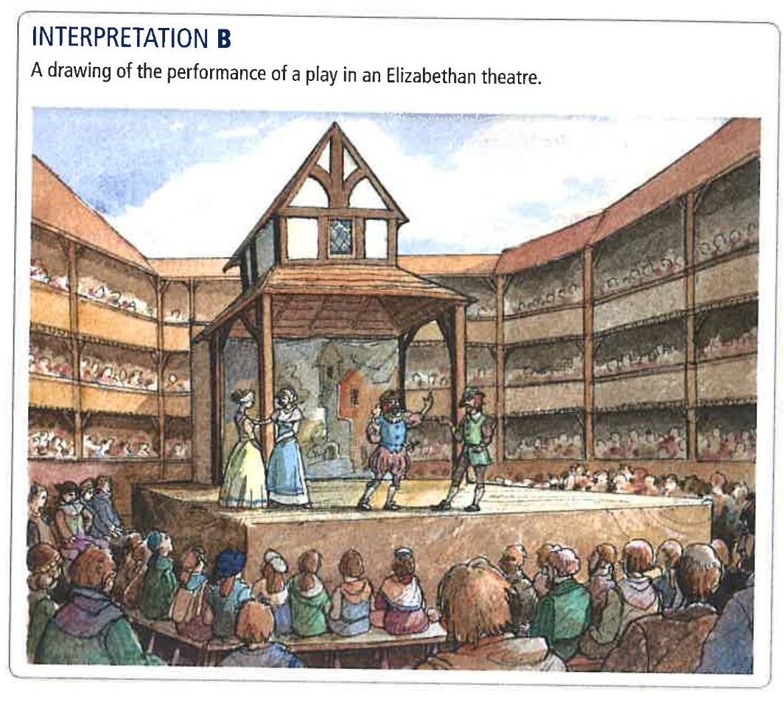

How convincing is Interpretation A about Elizabethan theatre? Explain your answer based on your contextual knowledge and what it shows in Interpretation A.

One way in which Interpretation A is convincing/unconvincing is because it shows/does not show…

From my own subject knowledge, …

A second way in which Interpretation A is convincing/unconvincing is because it shows/does not show…

From my own subject knowledge, …

A final way in which Interpretation A is convincing/unconvincing is because it shows/does not show…

From my own subject knowledge, …

Interpretation Question

Interpretation A

With incomparable skill Owen knew how to conduct priests to a place of safety along subterranean passages, to hide them between walls and bury them in impenetrable recesses, and to entangle them in labyrinths and a thousand windings. But what was much more difficult of accomplishment, he so disguised the entrances to these as to make them most unlike what they really were.
Allan Fea, Secret Chambers and Hiding Places, 1908.

How convincing is Interpretation A about how English Catholics opposed Elizabeth’s religious settlement? Explain your answer based on your contextual knowledge and what it says in Interpretation A.

One way in which Interpretation A is convincing/unconvincing is because it says/does not say…

From my own subject knowledge, …

A second way in which Interpretation A is convincing/unconvincing is because it says/does not say…

From my own subject knowledge, …

A final way in which Interpretation A is convincing/unconvincing is because it says/does not say…

From my own subject knowledge, …

Interpretation Question

Interpretation A
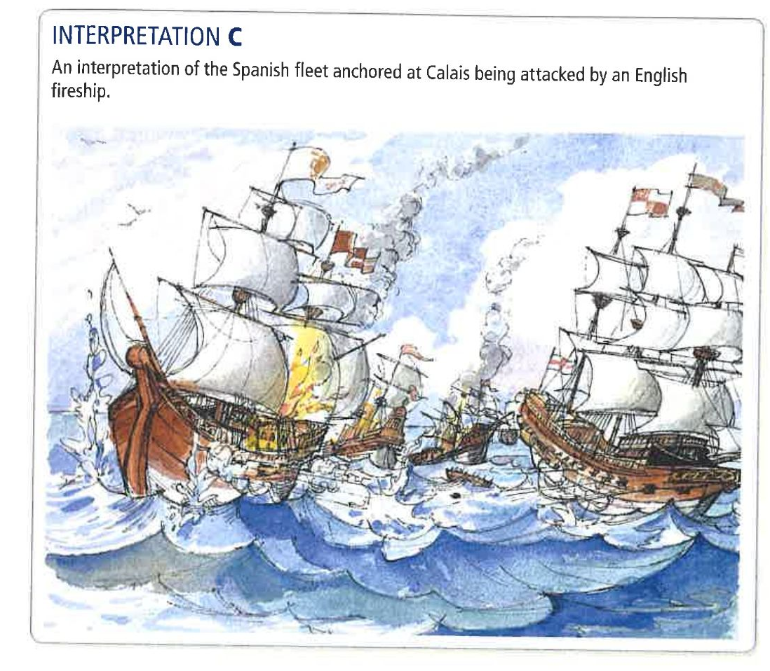

How convincing is Interpretation A about the reasons for the defeat of the Spanish Armada? Explain your answer based on your contextual knowledge and what it shows in Interpretation A.

One way in which Interpretation A is convincing/unconvincing is because it shows/does not show…

From my own subject knowledge, …

A second way in which Interpretation A is convincing/unconvincing is because it shows/does not show…

From my own subject knowledge, …

A final way in which Interpretation A is convincing/unconvincing is because it shows/does not show…

From my own subject knowledge, …

Interpretation Question

Interpretation A

Elizabeth adopted a tone of condescending superiority towards her Parliaments, confident that if she explained things often enough and slowly enough, the little boys would understand. For Elizabeth, parliamentarians were little boys – sometimes unruly and usually a nuisance, and always a waste of an intelligent woman’s time. Queen Elizabeth did not like Parliaments and it showed.
Christopher Haigh, 1988.

How convincing is Interpretation A about Elizabeth’s relationship with Parliament? Explain your answer based on your contextual knowledge and what it says in Interpretation A.

One way in which Interpretation A is convincing/unconvincing is because it says/does not say…

From my own subject knowledge, …

A second way in which Interpretation A is convincing/unconvincing is because it says/does not say…

From my own subject knowledge, …

A final way in which Interpretation A is convincing/unconvincing is because it says/does not say…

From my own subject knowledge, …

Interpretation Question

Interpretation A

Who was the queen’s husband to be, and what power was he to have over the government of the country? If he were a foreigner there was no knowing what power he might get over the queen, power which he would very likely use for the good of a foreign country, and not for the good of England. On the other hand, if he were an Englishman, he must be chosen from among the queen’s subjects, and then it was certain that there would be jealousy and strife among all the great nobles in the country when they saw one of their number picked out and made king over them.
Hugh Oakeley Arnold-Foster, A History of England, 1898.

How convincing is Interpretation A about the reasons why Elizabeth did not get married? Explain your answer based on your contextual knowledge and what it says in Interpretation A.

One way in which Interpretation A is convincing/unconvincing is because it says/does not say…

From my own subject knowledge, …

A second way in which Interpretation A is convincing/unconvincing is because it says/does not say…

From my own subject knowledge, …

A final way in which Interpretation A is convincing/unconvincing is because it says/does not say…

From my own subject knowledge, …

Interpretation Question

Interpretation A

These people who watched with joy the cruel torment of a bear or the execution of a Catholic also delighted in the romantic comedies of Shakespeare. These people were so appallingly gullible and ignorant, so brutal and childish compared with Englishmen of today, yet they set the standard of national greatness.
The Facts about Shakespeare, 1913.

How convincing is Interpretation A about the Elizabethan theatre? Explain your answer based on your contextual knowledge and what it says in Interpretation A.

One way in which Interpretation A is convincing/unconvincing is because it says/does not say…

From my own subject knowledge, …

A second way in which Interpretation A is convincing/unconvincing is because it says/does not say…

From my own subject knowledge, …

A final way in which Interpretation A is convincing/unconvincing is because it says/does not say…

From my own subject knowledge, …

Interpretation Question

Interpretation A

Unemployment was a major cause of poverty. When large landowners changed from arable to sheep farming, unemployment increased rapidly. The closing down of the monasteries in the 1530s created even more unemployment. As monasteries had also helped provide food for the poor, this created further problems. Unemployed people were sometimes tempted to leave their villages to look for work. This was illegal and people who did this were classified as vagabonds.
Spartacus Educational.

How convincing is Interpretation A about the causes of poverty in Elizabethan England? Explain your answer based on your contextual knowledge and what it says in Interpretation A.

One way in which Interpretation A is convincing/unconvincing is because it says/does not say…

From my own subject knowledge, …

A second way in which Interpretation A is convincing/unconvincing is because it says/does not say…

From my own subject knowledge, …

A final way in which Interpretation A is convincing/unconvincing is because it says/does not say…

From my own subject knowledge, …

Interpretation Question

Interpretation A

There were other plots against Elizabeth’s life in later years. However the revelations of the Ridolfi conspiracy coming so soon after the Northern Rebellion, alarmed her most. That her own cousin, the Duke of Norfolk, should have plotted her downfall was the cruellest blow she had yet suffered.
Neville Williams, The Life and Times of Elizabeth I, 1972.

How convincing is Interpretation A about the threats to Queen Elizabeth I? Explain your answer based on your contextual knowledge and what it says in Interpretation A.

One way in which Interpretation A is convincing/unconvincing is because it says/does not say…

From my own subject knowledge, …

A second way in which Interpretation A is convincing/unconvincing is because it says/does not say…

From my own subject knowledge, …

A final way in which Interpretation A is convincing/unconvincing is because it says/does not say…

From my own subject knowledge, …

Interpretation Question

Interpretation A

A serious criticism of Elizabeth was her failure to settle the succession. Despite pressure from her Council and marriage negotiations with several suitors, all were rejected. Her death before 1587 would probably have led to civil war. It seems unlikely that she had a deep-seated personal dislike of marriage but choosing a husband was difficult. Some suitors, like Leicester, were unacceptable to many councillors. The Catholic religion of suitors, such as Anjou, ruled them out. Elizabeth was lucky that she lived long enough for the problem to solve itself.
Adapted from an article by Penry Williams, in ‘History Review’, 1998.

How convincing is Interpretation A about Queen Elizabeth and marriage? Explain your answer based on your contextual knowledge and what it says in Interpretation A.

One way in which Interpretation A is convincing/unconvincing is because it says/does not say…

From my own subject knowledge, …

A second way in which Interpretation A is convincing/unconvincing is because it says/does not say…

From my own subject knowledge, …

A final way in which Interpretation A is convincing/unconvincing is because it says/does not say…

From my own subject knowledge, …

Interpretation Question

Interpretation A
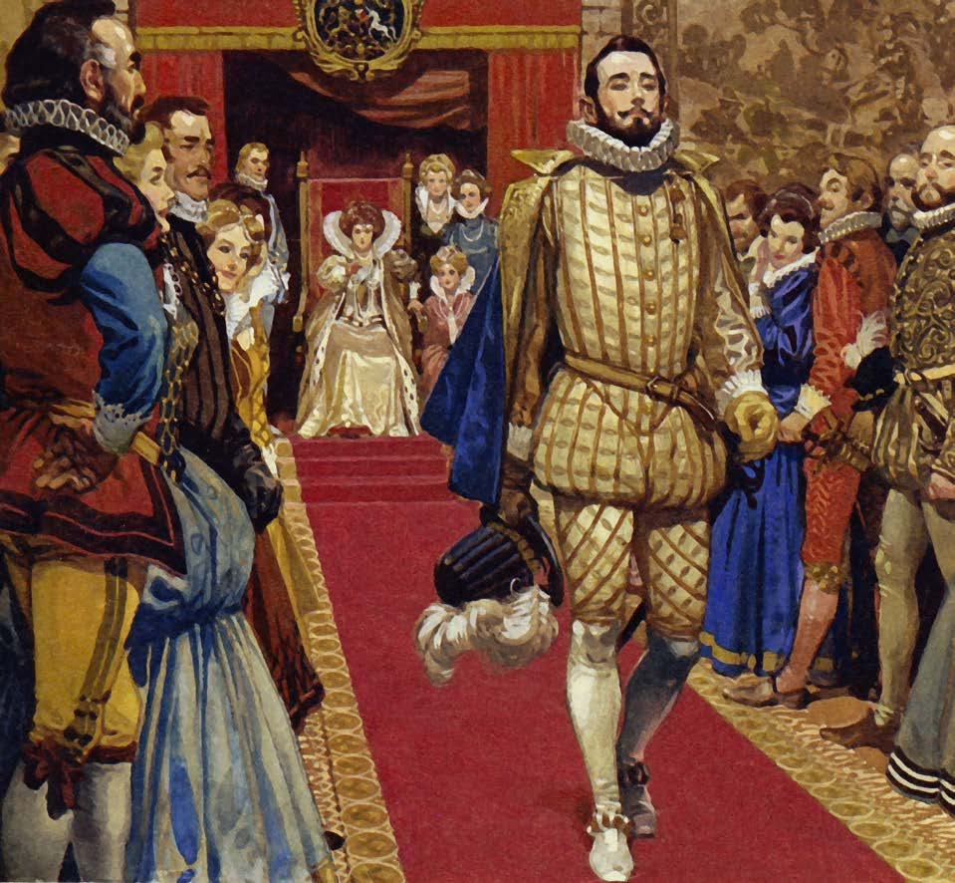

An interpretation of Sir Walter Raleigh. It depicts his dismissal from court. The picture was drawn for a children’s story book in the 1960s.

How convincing is Interpretation A about the career of Sir Walter Raleigh? Explain your answer based on your contextual knowledge and what it says in Interpretation A.

One way in which Interpretation A is convincing/unconvincing is because it shows/does not show…

From my own subject knowledge, …

A second way in which Interpretation A is convincing/unconvincing is because it shows/does not show…

From my own subject knowledge, …

A final way in which Interpretation A is convincing/unconvincing is because it shows/does not show…

From my own subject knowledge, …

Interpretation Question

Interpretation A

Was the real and secret purpose of Drake’s voyage to raid the wealth of Spain as an authorised privateer, or was he sent to discover new lands and set up British colonies in the New World? Was it simply a trading voyage with the aim of finding a new and profitable route to the spices of the East and done in secret to protect any commercial gains? Probably there was a mixture of motives, with much left to chance.
Adapted from an article by David Cressy, in ‘History Today’, 1981.

How convincing is Interpretation A about the motives for Drake’s round the world voyage? Explain your answer based on your contextual knowledge and what it says in Interpretation A.

One way in which Interpretation A is convincing/unconvincing is because it says/does not say…

From my own subject knowledge, …

A second way in which Interpretation A is convincing/unconvincing is because it says/does not say…

From my own subject knowledge, …

A final way in which Interpretation A is convincing/unconvincing is because it says/does not say…

From my own subject knowledge, …

Interpretation Question

Interpretation A

The Court was a home for monarch and courtiers, the centre of government and a place to show off. It was a market place for patronage, combining formal ceremony with a scramble for status, influence and profit. It was also a place of culture and entertainment. For Elizabeth, the Court was where she was on display, distributed patronage and kept contact with the great families of the kingdom. For most of her reign Elizabeth skilfully handled the competing noble groups while carrying out her policy and government. Tensions, however, became more obvious later on when royal control was challenged.
Adapted from an article by Penry Williams, in ‘History Review’, 1998.

How convincing is Interpretation A about the Elizabethan court? Explain your answer based on your contextual knowledge and what it says in Interpretation A.

One way in which Interpretation A is convincing/unconvincing is because it says/does not say…

From my own subject knowledge, …

A second way in which Interpretation A is convincing/unconvincing is because it says/does not say…

From my own subject knowledge, …

A final way in which Interpretation A is convincing/unconvincing is because it says/does not say…

From my own subject knowledge, …

Interpretation Question

Interpretation A

Essex soon charmed the elderly Queen when he arrived at Elizabeth’s court in his early twenties. He was tall, handsome and generous, but also arrogant and reckless. He showed daring but little judgement on military expeditions. Elizabeth gave him titles and a monopoly which made him wealthy but Essex was vain and jealous which made him easily offended and unwilling to be ruled by a woman. He failed in Ireland, which he blamed on enemies at Court. He then ignored Elizabeth’s orders by returning to England where he plotted to seize the Queen and take control of the government.
Adapted from an article by Richard Cavendish in ‘History Today’, 2001.

How convincing is Interpretation A about the Earl of Essex? Explain your answer based on your contextual knowledge and what it says in Interpretation A.

One way in which Interpretation A is convincing/unconvincing is because it says/does not say…

From my own subject knowledge, …

A second way in which Interpretation A is convincing/unconvincing is because it says/does not say…

From my own subject knowledge, …

A final way in which Interpretation A is convincing/unconvincing is because it says/does not say…

From my own subject knowledge, …

Interpretation Question

Interpretation A

During Queen Elizabeth’s reign there was revolutionary change in the theatre and an enormous growth in audiences. New theatres were built although some Puritans objected, and the City authorities tried to restrict playhouses. The theatre had Queen Elizabeth’s approval. All sorts of people watched plays which entertained and educated. Above all, Elizabethan playwrights made people think about their changing world and what it meant to be human.
An interpretation of the theatre in Elizabethan England. Adapted from ‘The Time Traveller’s Guide to Elizabethan England’ by Ian Mortimer, 2012.

How convincing is Interpretation A about the theatre in Elizabethan England? Explain your answer based on your contextual knowledge and what it says in Interpretation A.

One way in which Interpretation A is convincing/unconvincing is because it says/does not say…

From my own subject knowledge, …

A second way in which Interpretation A is convincing/unconvincing is because it says/does not say…

From my own subject knowledge, …

A final way in which Interpretation A is convincing/unconvincing is because it says/does not say…

From my own subject knowledge, …

Importance Question

Explain what was important about Elizabeth’s experiences before she became Queen.

One aspect of Elizabeth’s experience before she became Queen was…

For example…

This was important because…

A second aspect of Elizabeth’s experience before she became Queen was…

For example…

This was important because…

A final aspect of Elizabeth’s experience before she became Queen was…

For example…

This was important because…

Importance Question

Explain what was important about the Privy Council in Elizabeth’s reign.

One aspect of the Privy Council in Elizabeth’s reign was…

For example…

This was important because…

A second aspect of the Privy Council in Elizabeth’s reign was…

For example…

This was important because…

A final aspect of the Privy Council in Elizabeth’s reign was…

For example…

This was important because…

Importance Question

Explain what was important about the succession issue in Elizabethan England.

One aspect of the succession issue in Elizabethan England was…

For example…

This was important because…

A second aspect of the succession issue in Elizabethan England was…

For example…

This was important because…

A final aspect of the succession issue in Elizabethan England was…

For example…

This was important because…

Importance Question

Explain what was important about new ideas and fashions in Elizabethan England.

One aspect of the new ideas and fashions in Elizabethan England was…

For example…

This was important because…

A second aspect of the new ideas and fashions in Elizabethan England was…

For example…

This was important because…

A final aspect of the new ideas and fashions in Elizabethan England was…

For example…

This was important because…

Importance Question

Explain what was important about the gentry in Elizabethan times.

One aspect of the gentry in Elizabethan times was…

For example…

This was important because…

A second aspect of the gentry in Elizabethan times was…

For example…

This was important because…

A final aspect of the gentry in Elizabethan times was…

For example…

This was important because…

Importance Question

Explain what was important about population growth in the Elizabethan period.

One aspect of population growth in the Elizabethan period was…

For example…

This was important because…

A second aspect of population growth in the Elizabethan period was…

For example…

This was important because…

A final aspect of population growth in the Elizabethan period was…

For example…

This was important because…

Importance Question

Explain what was important about exploration in the Elizabethan period.

One aspect of exploration in the Elizabethan period was…

For example…

This was important because…

A second aspect of exploration in the Elizabethan period was…

For example…

This was important because…

A final aspect of exploration in the Elizabethan period was…

For example…

This was important because…

Importance Question

Explain what was important about the Papal Bull of 1570.

One aspect of the Papal Bull of 1570 was…

For example…

This was important because…

A second aspect of the Papal Bull of 1570 was…

For example…

This was important because…

A final aspect of the Papal Bull of 1570 was…

For example…

This was important because…

Importance Question

Explain what was important about Mary Queen of Scots’ presence in England between 1568 and 1587.

One aspect of Mary Queen of Scots’ presence in England between 1568 and 1587 was…

For example…

This was important because…

A second aspect of Mary Queen of Scots’ presence in England between 1568 and 1587 was…

For example…

This was important because…

A final aspect of Mary Queen of Scots’ presence in England between 1568 and 1587 was…

For example…

This was important because…

Importance Question

Explain what was important about the Spanish Netherlands during the Elizabethan period.

One aspect of the Spanish Netherlands during the Elizabethan period was…

For example…

This was important because…

A second aspect of the Spanish Netherlands during the Elizabethan period was…

For example…

This was important because…

A final aspect of the Spanish Netherlands during the Elizabethan period was…

For example…

This was important because…

Importance Question

Explain what was important about Mary, Queen of Scots during the Elizabethan period.

One aspect of Mary, Queen of Scots was…

For example…

This was important because…

A second aspect of Mary, Queen of Scots was…

For example…

This was important because…

A final aspect of Mary, Queen of Scots was…

For example…

This was important because…

Importance Question

Explain what was important about Elizabeth’s decision regarding her marriage.

One aspect of Elizabeth’s decision regarding her marriage was…

For example…

This was important because…

A second aspect of Elizabeth’s decision regarding her marriage was…

For example…

This was important because…

A final aspect of Elizabeth’s decision regarding her marriage was…

For example…

This was important because…

Importance Question

Explain what was important about exploration and trade in Asia for Elizabethan England.

One aspect of exploration and trade in Asia was…

For example…

This was important because…

A second aspect of exploration and trade in Asia was…

For example…

This was important because…

A final aspect of exploration and trade in Asia was…

For example…

This was important because…

Importance Question

Explain what was important about voyages of discovery in the reign of Elizabeth I.

One aspect of voyages of discovery in the reign of Elizabeth I was…

For example…

This was important because…

A second aspect of voyages of discovery in the reign of Elizabeth I was…

For example…

This was important because…

A final aspect of voyages of discovery in the reign of Elizabeth I was…

For example…

This was important because…

Importance Question

Explain what was important about the execution of Mary, Queen of Scots for Elizabethan England.

One aspect of the execution of Mary, Queen of Scots was…

For example…

This was important because…

A second aspect of the execution of Mary, Queen of Scots was…

For example…

This was important because…

A final aspect of the execution of Mary, Queen of Scots was…

For example…

This was important because…

Importance Question

Explain what was important about the navy for Elizabethan England.

One aspect of the Elizabethan navy was…

For example…

This was important because…

A second aspect of the Elizabethan navy was…

For example…

This was important because…

A final aspect of the Elizabethan navy was…

For example…

This was important because…

Importance Question

Explain what was important about the problem of poverty in Elizabethan England.

One aspect of the problem of poverty was…

For example…

This was important because…

A second aspect of the problem of poverty was…

For example…

This was important because…

A final aspect of the problem of poverty was…

For example…

This was important because…

Importance Question

Explain what was important about the rebellion of the Earl of Essex for Elizabethan England.

One aspect of Essex’s rebellion was…

For example…

This was important because…

A second aspect of Essex’s rebellion was…

For example…

This was important because…

A final aspect of Essex’s rebellion was…

For example…

This was important because…

Importance Question

Explain what was important about the arrival of Mary, Queen of Scots in England in 1568.

One aspect of the arrival of Mary, Queen of Scots in England in 1568 was…

For example…

This was important because…

A second aspect of the arrival of Mary, Queen of Scots in England in 1568 was…

For example…

This was important because…

A final aspect of the arrival of Mary, Queen of Scots in England in 1568 was…

For example…

This was important because…

Importance Question

Explain what was important about the Catholic plots against Queen Elizabeth I.

One aspect of the Catholic plots against Queen Elizabeth I was…

For example…

This was important because…

A second aspect of the Catholic plots against Queen Elizabeth I was…

For example…

This was important because…

A final aspect of the Catholic plots against Queen Elizabeth I was…

For example…

This was important because…

Importance Question

Explain what was important about Puritanism in Elizabethan England.

One aspect of Puritanism in Elizabethan England was…

For example…

This was important because…

A second aspect of Puritanism in Elizabethan England was…

For example…

This was important because…

A final aspect of Puritanism in Elizabethan England was…

For example…

This was important because…

Importance Question

Explain what was important about Queen Elizabeth I’s court.

One aspect of Queen Elizabeth I’s court was…

For example…

This was important because…

A second aspect of Queen Elizabeth I’s court was…

For example…

This was important because…

A final aspect of Queen Elizabeth I’s court was…

For example…

This was important because…

Write an account Question

Write an account of the ways in which a system of political patronage helped Elizabeth to govern England.

One way in which the system of political patronage helped Elizabeth to govern England was…

A second way in which the system of political patronage helped Elizabeth to govern England was…

A final way in which the system of political patronage helped Elizabeth to govern England was…

Write an account Question

Write an account of the ways in which the Earl of Essex affected Elizabethan England.

One way in which the Earl of Essex affected Elizabethan England was…

A second way in which the Earl of Essex affected Elizabethan England was…

A final way in which the Earl of Essex affected Elizabethan England was…

Write an account Question

Write an account of Elizabeth’s handling of the “marriage question”.

One way in which Elizabeth handled the “marriage question” was…

A second way in which Elizabeth handled the “marriage question” was…

A final way in which Elizabeth handled the “marriage question” was…

Write an account Question

Write an account of the ways in which Elizabeth used propaganda to strengthen her rule.

One way in which Elizabeth used propaganda was…

A second way in which Elizabeth used propaganda was…

A final way in which Elizabeth used propaganda was…

Write an account Question

Write an account of the ways in which poverty affected Elizabethan England.

One way in which poverty affected Elizabethan England was…

A second way in which poverty affected Elizabethan England was…

A final way in which poverty affected Elizabethan England was…

Write an account Question

Write an account of the ways in which Sir Walter Raleigh affected Elizabethan England.

One way in which Sir Walter Raleigh affected Elizabethan England was…

A second way in which Sir Walter Raleigh affected Elizabethan England was…

A final way in which Sir Walter Raleigh affected Elizabethan England was…

Write an account Question

Write an account of the ways in which Puritans posed a challenge to Elizabeth and her regime.

One way in which Puritans posed a challenge to Elizabeth and her regime was…

A second way in which Puritans posed a challenge to Elizabeth and her regime was…

A final way in which Puritans posed a challenge to Elizabeth and her regime was…

Write an account Question

Write an account of the ways in which Elizabeth and her government enforced the religious settlement.

One way in which Elizabeth and her government enforced the religious settlement was…

A second way in which Elizabeth and her government enforced the religious settlement was…

A final way in which Elizabeth and her government enforced the religious settlement was…

Write an account Question

Write an account of the ways Roman Catholics plotted to remove Elizabeth from the throne.

One way in which Roman Catholics plotted to remove Elizabeth from the throne was…

A second way in which Roman Catholics plotted to remove Elizabeth from the throne was…

A final way in which Roman Catholics plotted to remove Elizabeth from the throne was…

Write an account Question

Write an account of the ways in which Mary, Queen of Scots affected Elizabethan England.

One way in which Mary, Queen of Scots affected Elizabethan England was…

A second way in which Mary, Queen of Scots affected Elizabethan England was…

A final way in which Mary, Queen of Scots affected Elizabethan England was…

Write an account Question

Write an account of the ways in which conflict with Spain affected Elizabethan England.

One way in which conflict with Spain affected Elizabethan England was…

A second way in which conflict with Spain affected Elizabethan England was…

A final way in which conflict with Spain affected Elizabethan England was…

Write an account Question

Write an account of the problems Elizabeth faced in the first ten years of her reign.

One problem that Elizabeth faced was…

A second problem that Elizabeth faced was…

A final way problem that Elizabeth faced was…

Write an account Question

Write an account of the career of the Earl of Essex.

One aspect of the career of the Earl of Essex was…

A second aspect of the career of the Earl of Essex was…

A final aspect of the career of the Earl of Essex was…

Write an account Question

Write an account of the ways in which Elizabeth’s reign could be seen as a “golden age”.

One way in which Elizabeth’s reign could be seen as a “golden age” was…

A second way in which Elizabeth’s reign could be seen as a “golden age” was…

A final way in which Elizabeth’s reign could be seen as a “golden age” was…

Write an account Question

Write an account of the different ways in which towns and cities dealt with poverty in Elizabethan England.

One way in which towns and cities dealt with poverty in Elizabethan England was…

A second way in which towns and cities dealt with poverty in Elizabethan England was…

A final way in which towns and cities dealt with poverty in Elizabethan England was…

Write an account Question

Write an account of how the Poor Law system changed under Queen Elizabeth I.

One way in which the Poor Law system changed under Queen Elizabeth I was…

A second way in which the Poor Law system changed under Queen Elizabeth I was…

A final way in which the Poor Law system changed under Queen Elizabeth I was…

Write an account Question

Write an account of Elizabeth’s changing policy towards Catholics.

One policy that Elizabeth had towards Catholics was…

A different policy that Elizabeth had towards Catholics was…

A final policy that Elizabeth had towards Catholics was…

Write an account Question

Write an account of Puritanism during the reign of Elizabeth I.

One aspect of Puritanism during the reign of Elizabeth I was…

A second aspect of Puritanism during the reign of Elizabeth I was…

A final aspect of Puritanism during the reign of Elizabeth I was…

Write an account Question

Write an account of the ways in which the Northern Rebellion affected Elizabethan England.

One way in which the Northern Rebellion affected Elizabethan England was…

A second way in which the Northern Rebellion affected Elizabethan England was…

A final way in which the Northern Rebellion affected Elizabethan England was…

Write an account Question

Write an account of the ways in which Queen Elizabeth dealt with the challenge of Puritanism.

One way in which Queen Elizabeth dealt with the challenge of Puritanism was…

A second way in which Queen Elizabeth dealt with the challenge of Puritanism was…

A final way in which Queen Elizabeth dealt with the challenge of Puritanism was…

Write an account Question

Write an account of the ways in which the voyages of discovery affected Elizabethan England.

One way in which the voyages of discovery affected Elizabethan England was…

A second way in which the voyages of discovery affected Elizabethan England was…

A final way in which the voyages of discovery affected Elizabethan England was…

Write an account Question

Write an account of how poverty was dealt with during the reign of Queen Elizabeth I.

One way in which poverty was dealt with in Elizabethan England was…

A second way in which poverty was dealt with in Elizabethan England was…

A final way in which poverty was dealt with in Elizabethan England was…

Write an account Question

Write an account of the ways in which the theatre developed in Elizabethan England.

One way in which the theatre developed in Elizabethan England was…

A second way in which the theatre developed in Elizabethan England was…

A final way in which the theatre developed in Elizabethan England was…

Write an account Question

Write an account of how the Spanish Armada were defeated.

One way in which the Spanish Armada was defeated was…

A second way in which the Spanish Armada was defeated was…

A final way in which the Spanish Armada was defeated was…

Site Question

Introduction

First reason:
Evidence:

Explanation:

Second reason:
Evidence:

Explanation:

Third reason:
Evidence:

Explanation:

Conclusion

