Elizabeth’s Family

1. Who was Elizabeth’s father?

2. Who was Elizabeth’s mother?

3. Who were Elizabeth’s half-siblings?

4. Name two of Elizabeth’s step-mothers

5. Who were Elizabeth’s paternal grandparents? (Hint: Her father’s parents)

6. Who did Elizabeth’s half-sister marry? (Hint: He was a foreign ruler)

7. Who was Elizabeth’s cousin who she eventually executed in 1587?

8. What happened to Elizabeth’s mother?

Portraits of Elizabeth I
What are the hidden messages in these portraits?

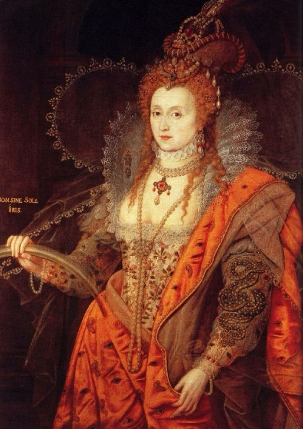
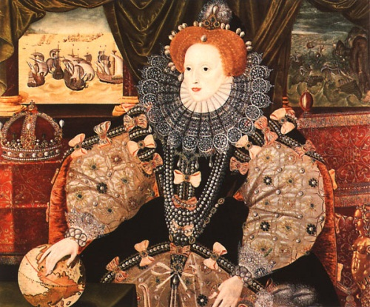
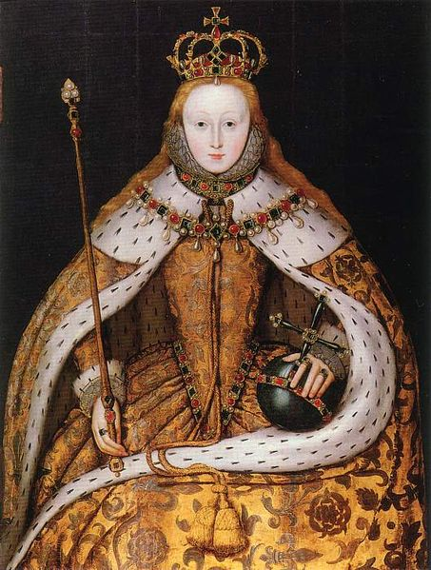
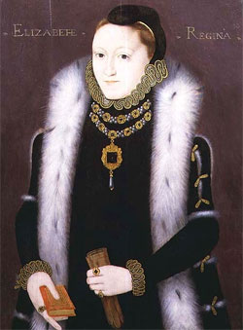
Elizabeth’s childhood during the reign of Henry VIII

1. What did the First Act of Succession, passed in 1533, say?

2. Why was Anne Boleyn executed?

3. What did the Second Act of Succession, passed in 1536, say?

4. Name Elizabeth’s governess

5. Name one of Elizabeth’s tutors

6. Identify three subjects that Elizabeth was taught by her tutors

7. How did Catherine Parr influence Elizabeth’s childhood?

8. What did the Third Act of Succession, passed in 1544, say?

Elizabeth’s youth during the reign of Edward VI and Mary I

1. What did Edward VI do to English Churches once he became king in January 1547?

2. Name the two men who acted as regents for Edward VI

3. What was the Seymour affair in which Elizabeth became embroiled in the late 1540s?

4. What did Elizabeth learn from this incident?

5. Who did Edward name as his heir in 1553? She reigned for nine days before being defeated by Mary I.

6. Why did Mary I view Elizabeth with suspicion?

7. Why did people participate in Wyatt’s Rebellion?

8. How was Elizabeth affected by the rebellion?

9. What happened to hundreds of Protestants during the reign of Mary I?

Elizabeth’s Government Part One

1. What was the Royal Court?

2. Identify three palaces that Elizabeth used

3. What were the different functions of the Royal Court?

4. What was a progress?

5. Why did Elizabeth go on progress?

6. What was patronage?

7. Why did Elizabeth use patronage? (Hint: Think about changing roles in the Privy Chamber)

8. Why did Elizabeth like the system of patronage? (Hint: What benefits did the system bring?)

Elizabeth’s Government Part Two

1. What was the role of the Privy Council?

2. What kind of people formed the Privy Council?

3. What was the Privy Council responsible for?

4. How similar was Elizabeth’s Privy Council compared to that of Mary I?

5. How did Elizabeth’s Privy Council change throughout her reign?

6. Name three members of Elizabeth’s Privy Council

7. How did Elizabeth manage her Privy Councillors to control their ambitions?

Elizabeth’s Government Part Three

1. What were the two parts of Parliament?

2. Describe the ‘upper’ house

3. Describe the ‘lower’ house

4. How many times did Parliament meet during Elizabeth’s reign?

5. What were Parliament’s two main functions?

6. How did the relationship between Elizabeth and Parliament change during her reign?

7. How did Elizabeth control Parliament?

Essex’s Rebellion

1. When did Essex rebel?

2. Who was Essex’s main rival on the Privy Council?

3. Why was Essex banished from court in the late 1590s?

4. In 1598, Elizabeth asked Essex to deal with a rebellion by…

5. Why was Essex banned from court on his return?

6. What did Essex lose as a punishment?

7. Describe three aspects of Essex’s rebellion

8. Why did Essex’s rebellion fail?

9. What happened to Essex?

The Succession Crisis

1. Why were people wary of a female ruler?

2. How did Elizabeth use the issue of marriage to her advantage?

3. Which parts of government “encouraged” Elizabeth to marry?

4. What were the advantages and disadvantages of the different marriage candidates?

 | Advantages | Disadvantages
King Philip of Spain

Robert Dudley

The Duke of Alençon

5. Why was pressure put on Elizabeth to name an heir and/or marry after 1562?

6. Name any possible heirs to Elizabeth’s throne

7. Who did inherit the throne in 1603?

Elizabethan Culture Part One

1. Which social group grew during the 16th century?

2. How did they start to show off their wealth?

3. Label the Elizabethan fashions

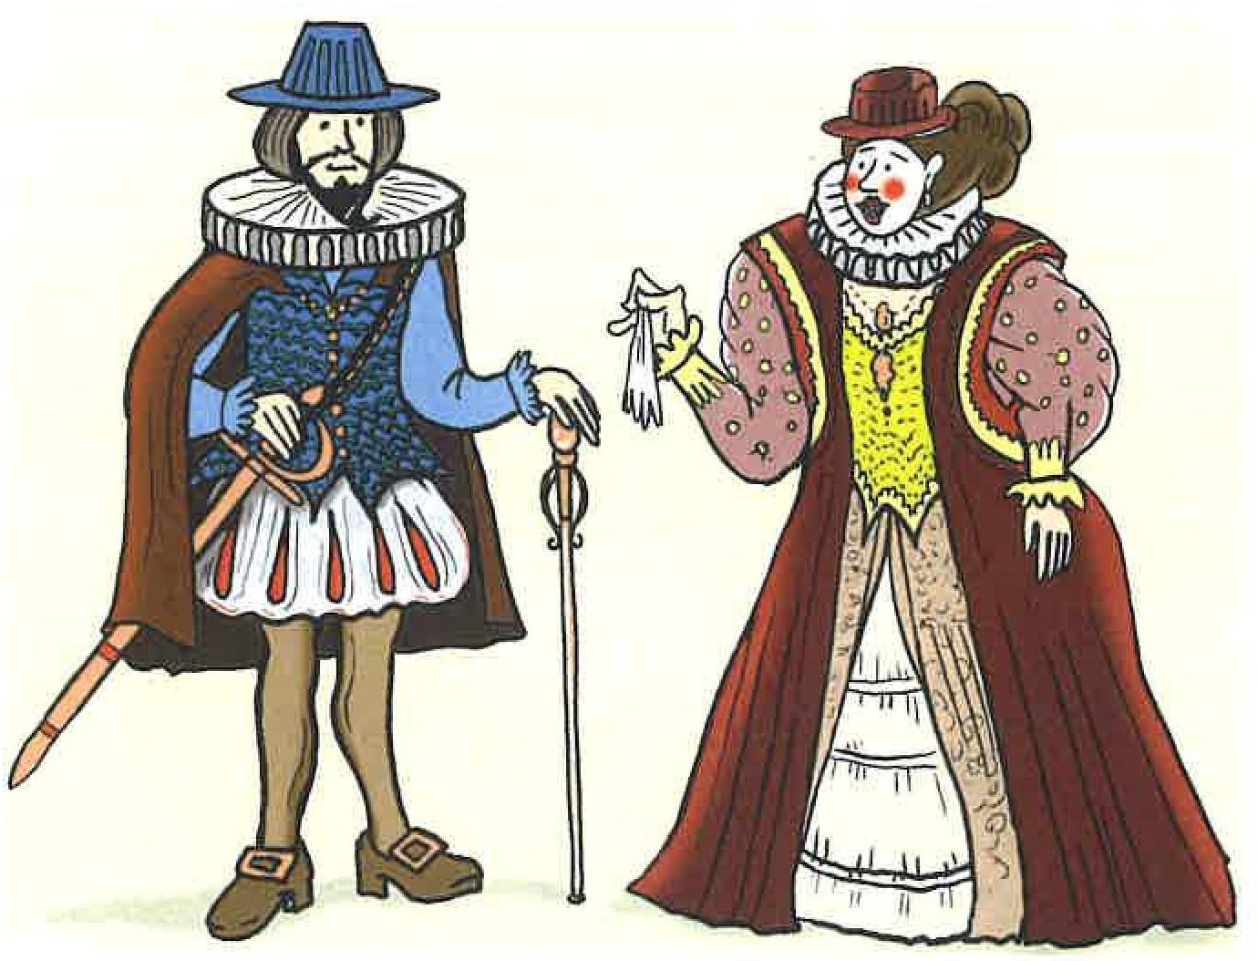

4. What did the Sumptuary Laws, passed in 1574, control?

5. Label the features of Elizabethan architecture

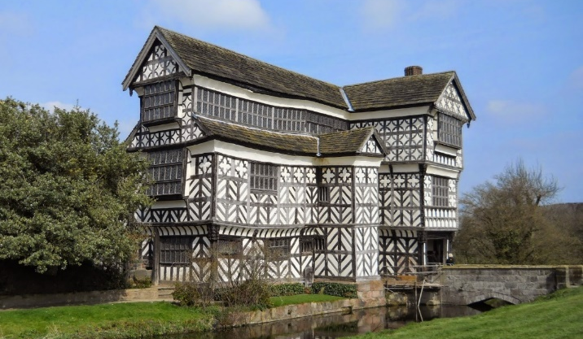

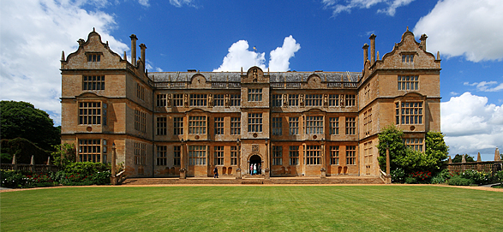
Elizabethan Culture Part Two

1. What kinds of plays were performed before Elizabeth’s reign?

2. How were actors viewed in the early years of Elizabeth’s reign?

3. Label the different features of the Globe Theatre
1 =

2 =

3 =

4 =

5 =

6 =

7 =

4. After 1572, all actors required a…

5. Why did people go to the theatre?

6. What kinds of people made up an audience at the theatre?

Elizabethan Culture Part Three

1. Name the playwright!

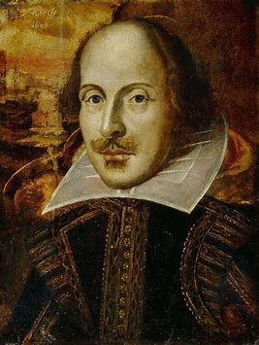 | 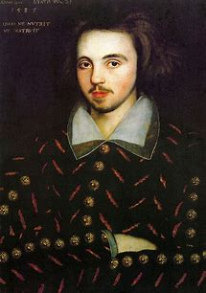 | 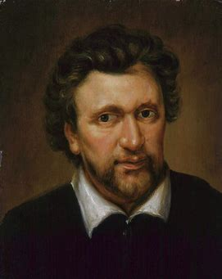

2. How did plays hold the attention of the audience?

3. Describe Elizabethan actors

4. How did the attitude of the ruling authorities change?

5. Why did their attitudes change?

6. What were the themes of the plays?

Elizabethan Poverty Part One

1. What were the causes of poverty in Elizabethan England?

Long-term: Henry VIII’s reign and before | Medium-term: The reign of Edward VI and Mary I | Short-term: The reign of Elizabeth I

2. Who were the ‘impotent poor’?

3. What did people think of them?

4. Who were the ‘idle poor’?

5. What did people think of them?

Elizabethan Poverty Part Two

1. What the government’s attitude to the problem of poverty at the beginning of Elizabeth’s reign?

2. What kinds of schemes were set up in local areas? (Hint: Norfolk and London)

3. Why did Elizabeth and her government decide to act in the 1590s?

4. Show off your knowledge of the different aspects of the 1601 Poor Law
(a) Poor Rate

(b) Outdoor Relief

(c) Overseer

(d) Alms-house

(e) House of Industry

(f) House of Correction

5. Why was the 1601 Elizabethan Poor Law an important milestone?

Elizabethan Exploration Part One

1. What kinds of goods were brought into Europe from the East?

2. Why was it increasingly difficult to trade with the East?

3. How did each of these ideas and inventions help exploration?

Belief that the world was round  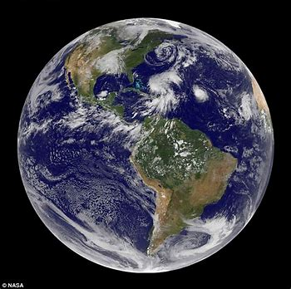 | The Printing Press  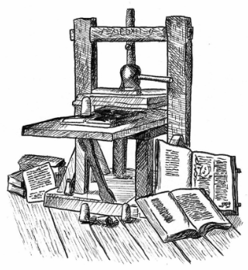
The Astrolabe  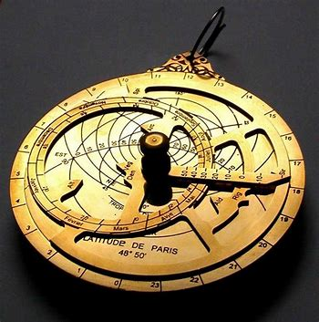 | The invention of the rudder and triangular sail  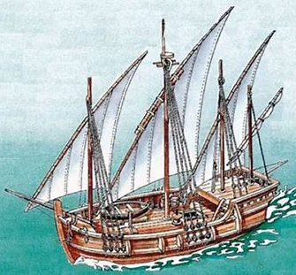

4. Identify explorers who had discovered new lands before the reign of Elizabeth I

5. How did Spain and Portugal become incredibly rich through exploration?

Elizabethan Exploration Part Two

1. What can you remember about the different aims of Elizabethan exploration?

Aims of the voyages | Examples | How far were the aims achieved? Success or failure?
To trade and bring back riches

To find a northerly sea route to India or China

To attack Spanish settlements in Central America

To establish English settlements overseas (colonies)

The Elizabethan Religious Settlement

1. What did the 1559 Act of Supremacy do?

2. What title did Elizabeth adopt? Why?

3. What did the act require/keep?

4. What was the purpose of the 1559 Act of Uniformity?

5. What was included?

Catholic ideas | Protestant ideas

6. Why was the Elizabethan Religious Settlement a compromise? What was its purpose?

The Catholic threat

1. How were Catholics who refused to accept the Elizabethan Religious Settlement punished?

2. Where was a Catholic seminary (training school for priests) set up in 1568?

3. Who rebelled in the 1569 Northern Rebellion?

4. What did Pope Pius do in 1570?

5. What did the 1571 Treason Act say?

6. In 1580, Catholic priests arrived in England. They were from a group called the…

7. They tried to avoid arrest by…

8. What happened to these priests if they were caught?

9. What other measures were introduced in the 1580s and 1590s to control the Catholic threat?

10. How did the Pope make it difficult for English Catholics to support moves against Elizabeth?

The Puritan threat

1. Which parts of the Elizabethan Religious Settlement were the Puritans unhappy with?

2. In which part of the government were Puritans particularly vocal?

3. How did Elizabeth control this?

4. Why was Archbishop Edmund Grindal placed under house arrest?

5. Who was Grindal’s replacement as Archbishop of Canterbury?

6. How did he control the Puritan threat?

7. Who were the Separatists?

8. How did the government deal with their threat?

Mary, Queen of Scots Part One

1. How was Mary, Queen of Scots, related to Elizabeth I?

2. Bullet point three things about Mary’s parents and/or childhood

3. Which religion did Mary follow?

4. Who did Mary marry in 1558? What happened to him?

5. What was the religious situation in Scotland when Mary returned in 1561?

6. Who was Mary’s second husband? Why did this marriage annoy Elizabeth?

7. Who was Mary’s third husband? Why was this marriage controversial?

8. What was Mary forced to do in 1567?

9. What was the name of her son who became king in 1567?

Mary, Queen of Scots Part Two

1. Where did Mary flee to after escaping captivity in Scotland in 1568?

2. Why was her presence in England considered to be such a threat to Elizabeth I?

3. The 1569 Northern Rebellion
(a) Which duke played a central role in the 1569 rebellion?

(b) Why did he become involved?

(c) What was the intention of the rebels?

(d) Who else joined the rebellion?

(e) Although ordered not to rebel by (a), rebels in the north…

(f) Why did the rebellion fail?

(g) How did Elizabeth deal with the rebels?

Mary, Queen of Scots Part Three

1. The 1571 Ridolfi Plot
(a) Who participated in the plot?

(b) What was the intention of the rebels?

(c) Why was this plot more dangerous than previous plots? (Hint: What had happened in 1570?)

(d) How did Elizabeth deal with the rebels?

2. The 1583 Throckmorton Plot
(a) Who participated in the plot?

(b) What was the intention of the rebels?

(c) Whose spy network uncovered the plot?

(d) How did Elizabeth deal with the rebels/rebellion?

Mary, Queen of Scots Part Four

1. The 1586 Babington Plot
(a) How was Mary ‘pushed’ into participating in the 1586 plot? (Hint: Think about the conditions of her imprisonment)

(b) Who participated in the plot?

(c) What was the intention of the rebels?

(d) How was the plot uncovered?

2. The trial and execution of Mary, Queen of Scots
(a) Where was Mary’s trial held? (Hint: It was the same place as her execution)

(b) Why was Elizabeth reluctant to sign Mary’s death warrant?

(c) Why was Elizabeth angry once Mary had been executed?

(d) How did Catholics, at home and abroad, react to Mary’s execution?

Conflict with Spain Part One

1. What had Philip II done in 1559? (Hint: Elizabeth’s rejection angered him.)

2. What was Philip’s view of Elizabeth as a Protestant? What did he do as a result?

3. The Spanish Netherlands:
(a) Which religion was followed by most people in the Netherlands?

(b) Which religion was followed by most people in Spain?

(c) What happened in 1566 in the Netherlands? How did Philip react?

(d) Why did Elizabeth want to reduce Spanish influence in the Netherlands?

(e) What kind of unofficial help was sent to the Dutch rebels?

4. How were English sailors an annoyance to Spain?

5. What was the 1584 Treaty of Joinville? Why was this a threat to England?

6. What was the 1585 Treaty of Nonsuch?

7. What was the “final straw” for Philip in 1587?

Conflict with Spain Part Two

1. Label the image with the different people and the hidden symbolism.

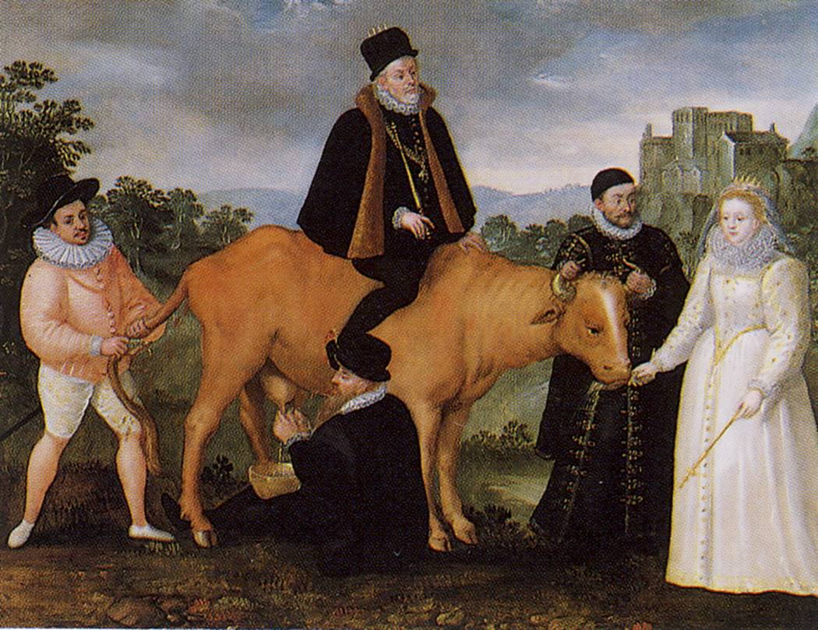

2. Think about the preparations by both sides: think about leadership and resources.

 | Strengths | Weaknesses
Spain

England

Conflict with Spain Part Three

1. What was the plan for the Spanish Armada?

2. What can you remember about the Spanish galleons and their crescent formation?

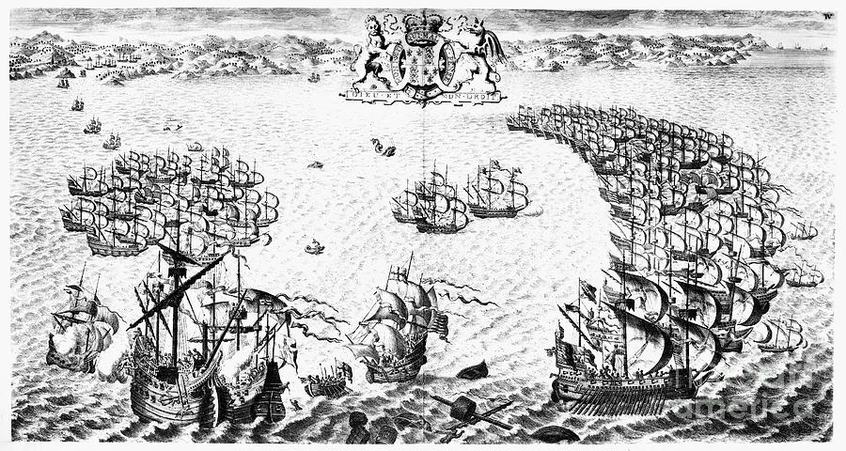

3. How did the English send news of the approach of the Spanish Armada?

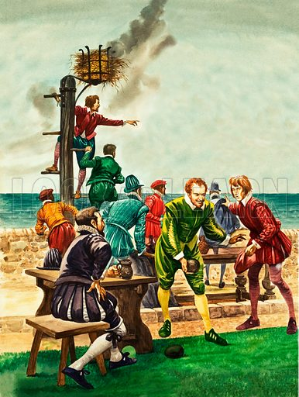

4. What can you remember about the English ships?

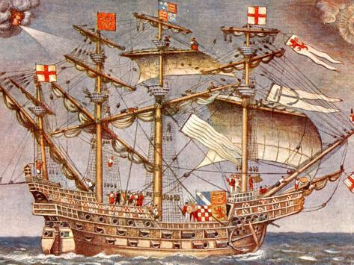

Conflict with Spain Part Four

1. What can you remember about the route of the Spanish Armada?
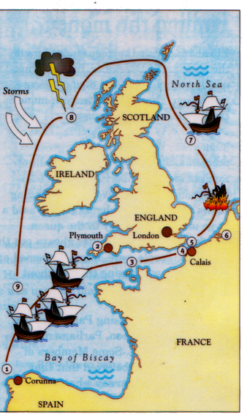

2. What can you remember about the reasons for the defeat of the Spanish Armada?

English strengths | Spanish weaknesses | Luck

The “Golden Age”?

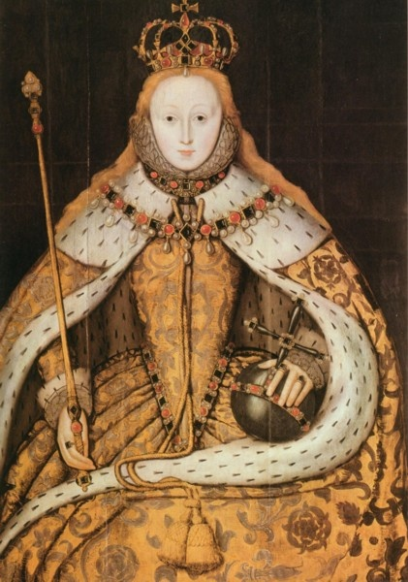

Does the reign of Elizabeth deserve to be called a “Golden Age”?

Yes | No

