Democracy and Dictatorship: Germany before 1890-1919

1. Identify ways in which Kaiser Wilhelm’s government was strong before 1918

2. Identify ways in which Kaiser Wilhelm’s government was weak before 1918

3. How did WWI change the lives of ordinary Germans?

4. What did Kaiser Wilhelm do in November 1918? Why?

5. What were the terms of the Treaty of Versailles?

Democracy and Dictatorship: Germany 1920-1923

1. What were the causes of the 1923 hyperinflation?

2. How did the German government deal with the 1923 hyperinflation?

3. How were people affected by the 1923 hyperinflation?

4. How did the 1923 hyperinflation affect views of the Weimar Republic?

5. What were the strengths and weaknesses of the role of President?

6. What were the strengths and weaknesses of the role of Chancellor?

7. What were the strengths and weaknesses of the role of the Reichstag?

8. What can you remember about the Spartacists and Communist revolts?

9. What can you remember about the Kapp Putsch?

10. What can you remember about the Munich Putsch?

Democracy and Dictatorship: Germany 1923-1929

1. How did Stresemann help Germany to recover after 1923?

The Rentenmark

Dawes Plan

The Locarno Pact

The League of Nations

The Young Plan

2. Describe art and culture under Kaiser Wilhelm II.

3. Describe art and culture in Weimar Germany.

4. How would critics of the art and culture view the Weimar government?

Democracy and Dictatorship: The rise of the Nazi Party

1. What happened to the number of Reichstag seats held by the Nazis? Describe the pattern between 1928 and 1933.

2. The Wall Street Crash
(a) What caused the crash?

(b) What were the effects on different groups of people?

(c) How did the German government react to the Wall Street Crash?

(d) How did the Wall Street Crash affect views of the Weimar government?

3. What techniques did the Nazis use to increase their share of the votes?

4. What were the other factors, outside of their control, that helped the Nazis to increase their share of the votes?

Democracy and Dictatorship: Hitler Chancellor and Dictator

1. Franz von Papen

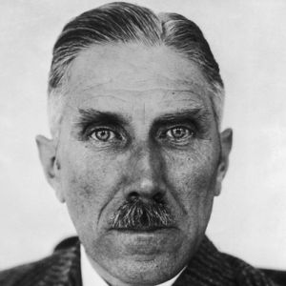
Who was he?

How did he help Hitler to become Chancellor?

2. General von Schleicher

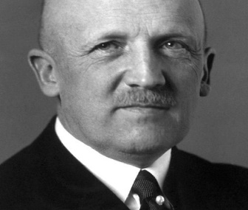
Who was he?

How did he help Hitler to become Chancellor?

3. President Hindenburg

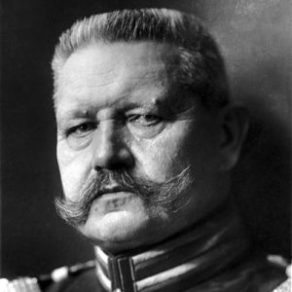
Who was he?

How did he help Hitler to become Chancellor?

4. How did Hitler become a dictator?

The Reichstag Fire

The Enabling Law

Trade unions

Other political parties

The Night of the Long Knives

Hindenburg’s death

Democracy and Dictatorship: Nazi economic policies

1. How far did unemployment fall between 1933 and 1939?

2. What kinds of jobs did the Nazis create?

3. What was the National Labour Service?

4. Who were omitted from the employment figures?

5. What was the Four Year Plan?

6. How did the Nazis treat industrial workers?

7. How did the Nazis treat farmers?

8. How did the Nazis treat business owners?

9. How did WWII affect the German economy?

Democracy and Dictatorship: Nazi policies on women and children

1. Women
(a) What did the Nazis see as the ideal woman?

(b) What policies did they have to achieve the ideal woman?

(c) How did WWII affect the lives of women in Germany?

2. Children and young people
(a) How were schools changed?

(b) Activities and purpose of the Hitler Youth?

(c) Activities and purpose of the League of German Maidens?

(d) How did some young people oppose the Nazis?

(e) How did youth policies change after 1939?

Democracy and Dictatorship: Nazi social policies Part One

1. Identify different social groups that the Nazis thought were inferior – why did they see them as inferior?

2. What were the Nazis policies towards these different social groups? How did they treat them?

3. How could you describe the pattern of treatment of these social groups?

4. Describe the relationship between the Nazis and the Church

Democracy and Dictatorship: Nazi social policies Part Two

1. What can you remember about how the rights of social groups were denied?

2. What can you remember about how different social groups were separated from the rest of society?

3. What can you remember about the killings of different social groups?

4. What can you remember about the genocide perpetrated by the Nazis?

Democracy and Dictatorship: The Nazi totalitarian state

1. What was the role of the SS?

2. What was the role of the Gestapo?

3. What was the role of the police and courts?

4. What was the role of concentration camps?

5. How did people oppose the Nazi totalitarian state?

Private resistance

White Rose Group

The Stauffenberg Plot

Democracy and Dictatorship: Nazi propaganda

1. What can you remember about Nazi propaganda methods?

Newspapers

Films

Radio

Festivals and rallies

Music, theatre and literature

Art and architecture

2. What was the name of the Minister for Propaganda?

