‘The Door’

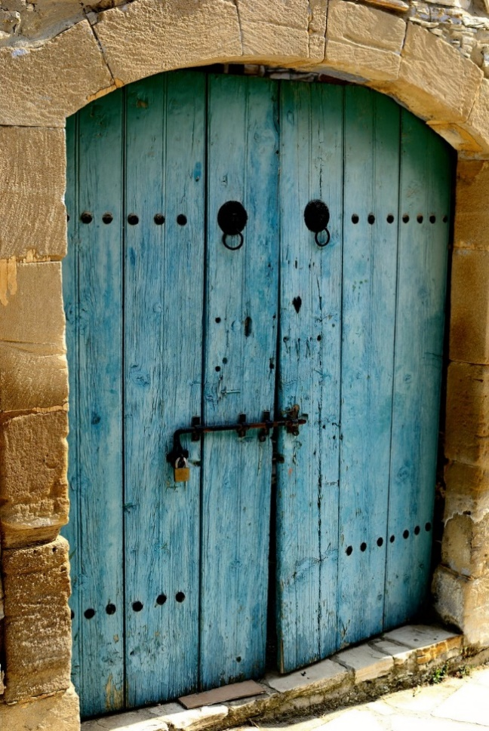

By …………………………………

………………………………………………………………………………………………………………………………………………………………………………………………………………………………………………………………………………………………………………………………………………………………………………………………………………………………………………………………………………………………………………………………………………………………………………………………………………………………………………………………………………………………………………………………………………………………………………………………………………………………………………………………………………………………………………………………………………………………………………………………………………………………………………………………………………………………………………………………………………………………………………………………………………………………………………………………………………………………………………………………………………………………………………………………………………………………………………………………………………………………………………………………………………………………………………………………………………………………………………………………………………………………………………………………………………………………………………………………………………………………………………………………………………………………………………………………………………………………………………………………………………………………………………………………………………………………

