Conflict and Tension: Europe in 1914

1. What was the name of the alliance made up of Britain, France and Russia?

2. Strengths and weaknesses of Britain in 1914?

3. Strengths and weaknesses of France in 1914?

4. Strengths and weaknesses of Russia in 1914?

5. What was the name of the alliance made up of Germany, Austria-Hungary and Italy?

6. Strengths and weaknesses of Germany in 1914?

7. Strengths and weaknesses of Austria-Hungary in 1914?

8. Strengths and weaknesses of Italy in 1914?

Conflict and Tension: Causes of WWI

What can you remember about the different causes of WWI?

Militarism  Arms race | Alliances  Triple Entente  Triple Alliance
Imperialism  Kaiser Wilhelm’s ambitions  Morocco Crisis of 1905  Morocco Crisis of 1906  Morocco Crisis of 1911 | Nationalism  The assassination of Archduke Franz Ferdinand

Conflict and Tension: Stalemate and Trenches

1. What was the theory of the Schlieffen Plan?

2. Why did the Schlieffen Plan fail?

3. What can you remember about the Battle of the Marne?

4. What did the failure of the Schlieffen Plan lead to?

5. Label the cross-section of the front-line trench.

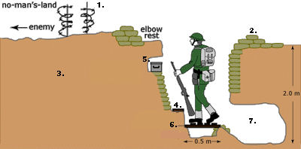

6. What kinds of trenches were there?

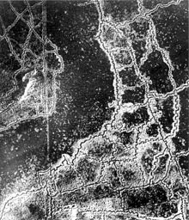
Conflict and Tension: Trench Conditions

1. What equipment was a soldier given?

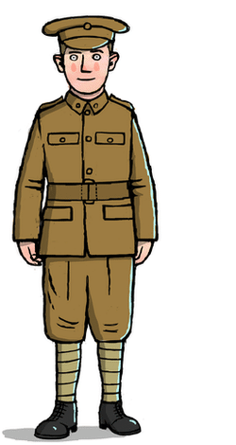

2. What can you remember about
(a) Jobs in the trenches?

(b) Food in the trenches?

(c) Health and hygiene in the trenches?

(d) Time off from the front-line?

(e) Rules and discipline in the trenches?

Conflict and Tension: Technology

What can you remember about artillery?
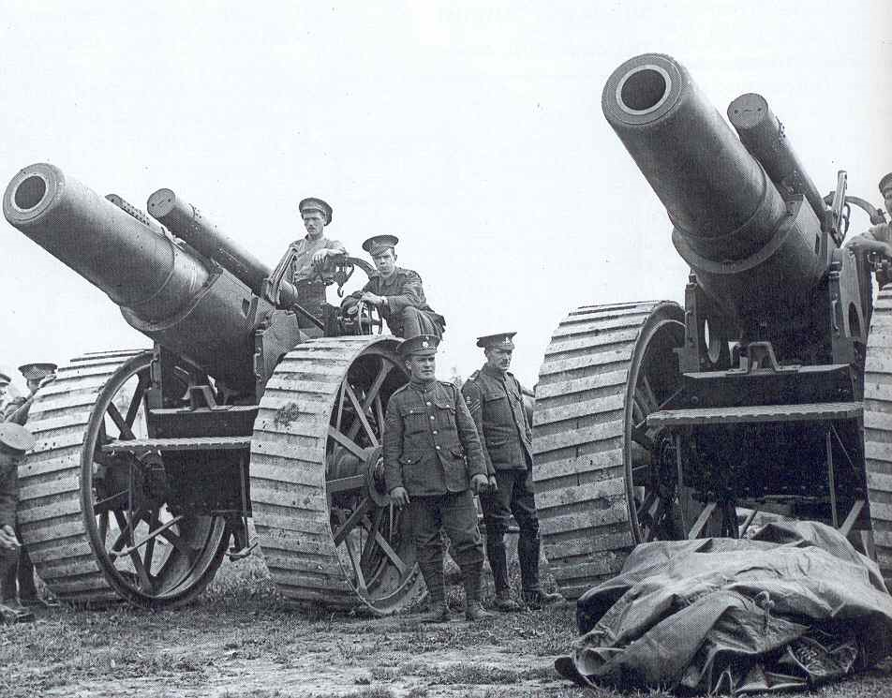

What can you remember about machine guns?
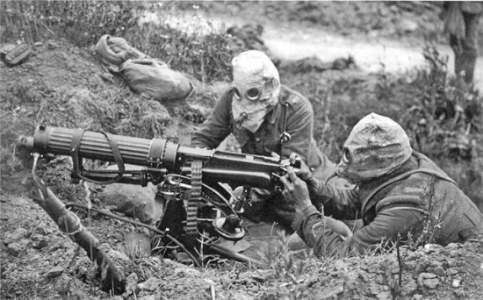

What can you remember about aircraft?
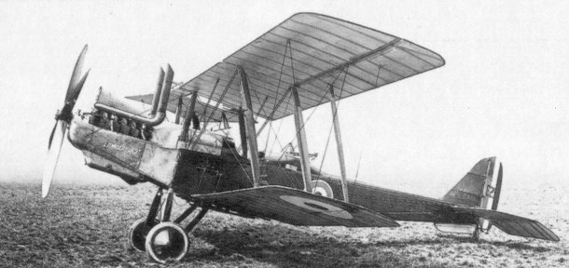

What can you remember about tanks?
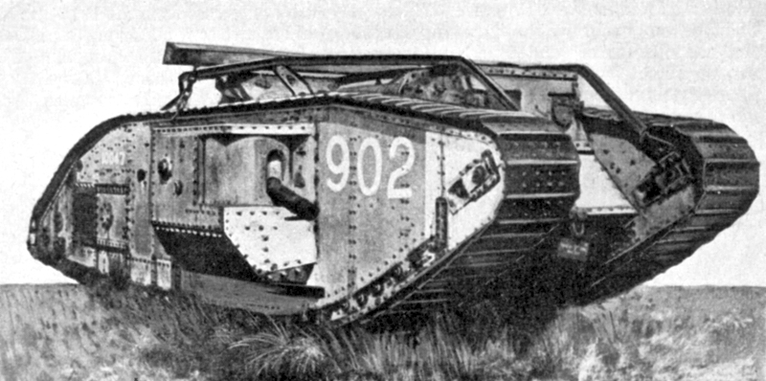

What can you remember about gas?
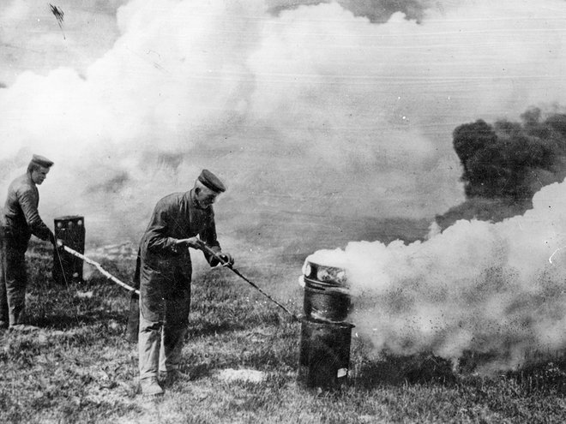

Conflict and Tension: WWI Battles

1. What can you remember about the Battle of the Somme?
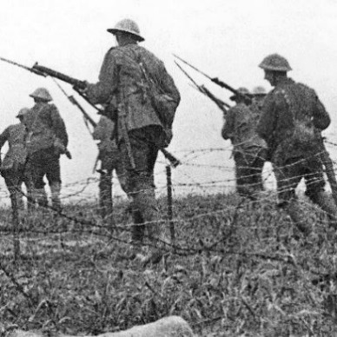

2. What can you remember about the Battle of Verdun?
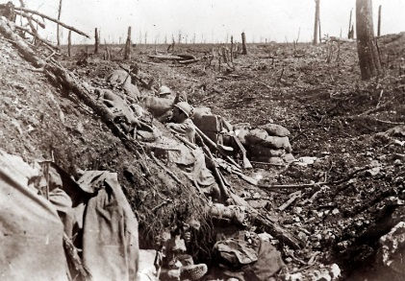

3. What can you remember about the Battle of Passchendaele?
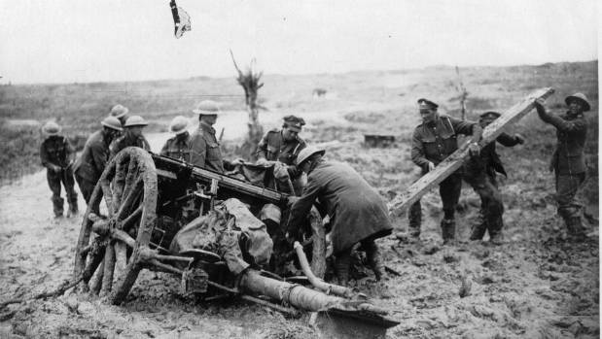

4. What can you remember about Gallipoli?
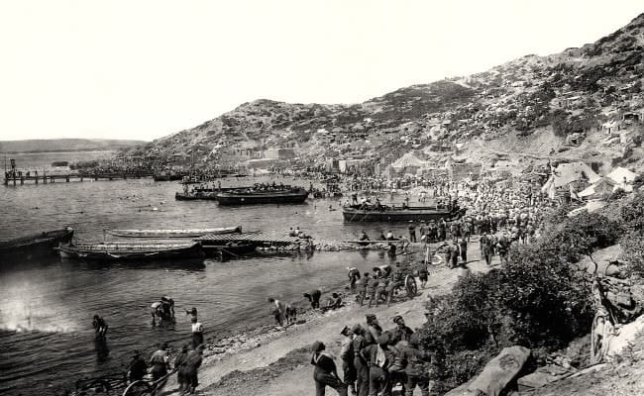

5. What can you remember about the war at sea?
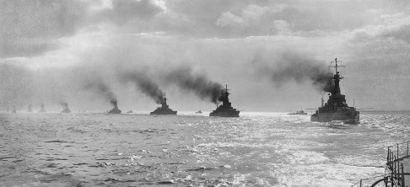

Conflict and Tension: The end of WWI

1. How did the following contribute to the end of WWI?

German attacks on shipping
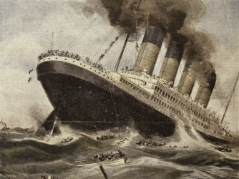

The entry of the USA into the war
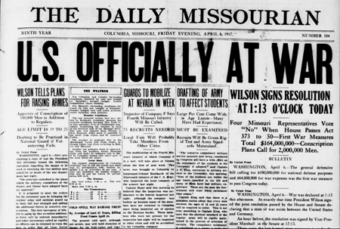

Blockades of German ports
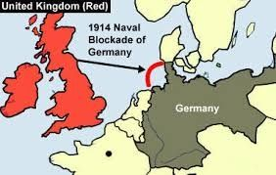

The failure of the Ludendorff Offensive
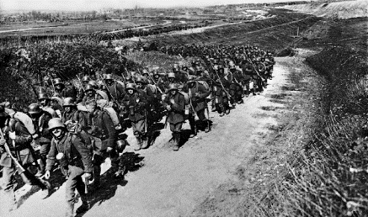

The Hundred Days Offensive
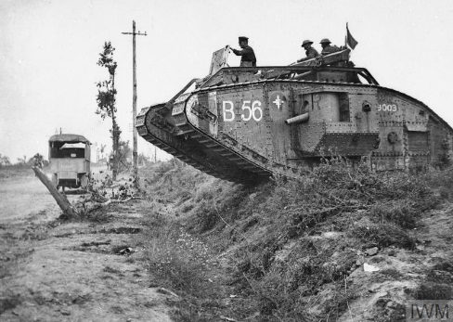

Conflict and Tension: The Armistice

1. Why did Kaiser Wilhelm abdicate?
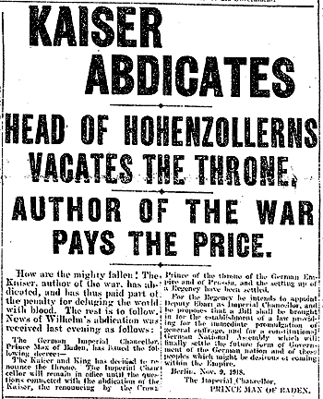

2. What were Wilson’s Fourteen Points?
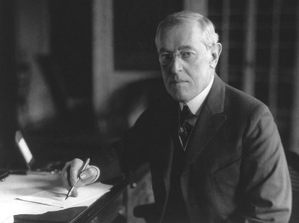

3. When, where and by whom was the armistice signed?
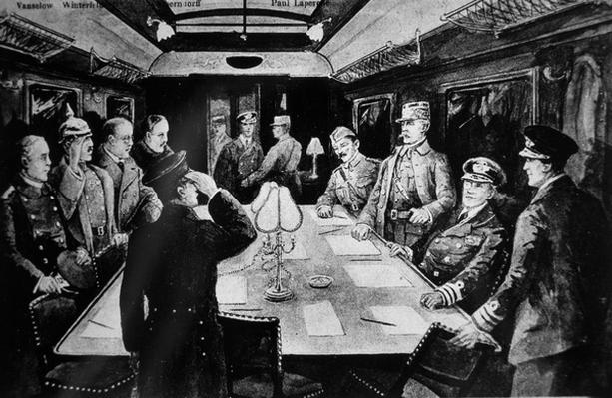

4. What were the terms of the armistice?
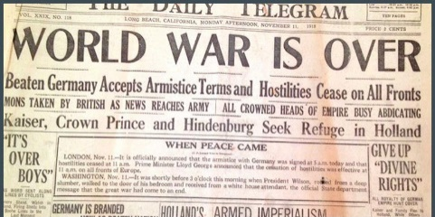

5. How did people react to the armistice?
